Supervisor Match
SETAP referral and deferral coursework report
Module | Software Engineering Theory and Practice
Coursework | Individual prototype for staff project supervision matching
Prepared by | Essam Tamer
UP number | 2555176
Date | 30 July 2026

This report documents a working web prototype that allows staff to maintain areas of interest and project ideas, while students can browse staff profiles to find a suitable supervisor. The structure follows the coursework brief and the marking scheme, with clear traceability from interview evidence to requirements, design, implementation and testing.
Chapter 1: Problem Specification
1.1 Problem Context
Final year students need to choose a project topic and identify an appropriate academic supervisor. In the current problem context, supervisor information can be spread across staff pages, emails, module documents and informal advice. This makes comparison difficult because students may not know which staff member has relevant interests, available project ideas or remaining capacity.
The prototype addresses this by providing a single place where staff profiles, interests and project ideas can be maintained and browsed. Staff can create, update and delete their own profile information, areas of interest and proposed projects. Students can browse the profiles and search by topic, staff details or project titles.
1.2 Requirements Elicitation Process
I used short semi structured interviews because the system has two clear user groups and the coursework required evidence of actual requirements gathering. Students were the main group because they are the people browsing for supervisors. A tutor perspective was added because staff are responsible for maintaining profiles and project ideas.
The data set contained four anonymised interview records: S1 on 10 July 2026, S2 on 12 July 2026, S3 on 15 July 2026 and T1 on 17 July 2026. Consent was recorded for each participant. The questions asked about how students currently find supervisors, what information is missing, how topic search should work, what staff need to update and what features would make the system more trustworthy.
The analysis used a simple thematic coding process. First, I read the notes and marked repeated ideas. Second, similar points were grouped into themes such as topic discovery, availability and staff maintenance. Third, each theme was translated into user requirements. Finally, the user requirements were converted into functional and non functional system requirements with acceptance criteria.
This method is proportionate to the prototype scope. The main limitation is that the sample is small and based on convenience participants, so the findings support a coursework prototype rather than a full university deployment.
Theme | Evidence | Design impact
Centralised information | S1, S2, S3 and T1 described information being spread across staff pages, emails, module documents or informal communication. | A single browse area and public profile page were implemented.
Topic based discovery | All participants wanted search by topic or area, including AI, data science, cybersecurity, web development and machine learning. | Search checks staff names, departments, biographies, areas and project titles.
Consistent profile content | Students wanted clearer expertise, experience, contact and project information. T1 supported a consistent profile format. | Each profile uses the same fields for comparison.
Project availability | All participants referred to availability, capacity, spaces or project status. | Project records include capacity, level and status.
Staff self maintenance | All participants said staff should update details, interests and project ideas without technical help. | The staff workspace supports create, update and delete actions.
Usability and mobile access | Students wanted simple navigation, short results and mobile access. The tutor wanted clear navigation. | The interface uses search, profile cards and responsive CSS.
Data currency | Participants warned that outdated information would reduce trust. | Staff updates are implemented. Last updated dates and reminders are future work.

1.3 User Requirements
ID | User requirement | Source
UR1 | Staff should be able to create and maintain their own profile details. | Brief, S1, S2, S3, T1
UR2 | Staff should be able to add, update and remove areas of interest. | Brief, S1, S2, S3, T1
UR3 | Staff should be able to add, update and remove proposed project ideas. | Brief, S1, S2, S3, T1
UR4 | Students should be able to browse staff profiles in a consistent format. | Brief, S1, S2, S3, T1
UR5 | Students should be able to search by topic, area, staff details or project idea. | S1, S2, S3, T1
UR6 | Students should be able to see project status, capacity and suitability information before contacting staff. | S1, S2, S3, T1
UR7 | The system should be quick, simple and readable on mobile width screens. | S1, S2, S3, T1

1.4 System Requirements
ID | Type | Linked user requirement | System requirement | Acceptance criteria
FR1 | Functional | UR1 | The system shall allow staff profiles to be created, updated and deleted. | Valid profile details can be saved, changed and removed.
FR2 | Functional | UR2 | The system shall allow areas of interest to be added and removed from staff profiles. | Areas appear on the public staff profile and can be removed.
FR3 | Functional | UR3 | The system shall allow staff project ideas to be created, edited and deleted. | Project title, description, level, capacity and status are stored and displayed.
FR4 | Functional | UR4 and UR5 | The system shall allow students to browse and search staff profiles. | Search returns matching staff by name, department, area or project title.
NFR1 | Non functional | UR7 | The interface should be usable on desktop and mobile width screens. | The layout remains readable at a narrow viewport.
NFR2 | Non functional | UR1, UR2 and UR3 | The system should preserve saved profile, area and project data between sessions. | SQLite stores data after the database connection is reopened.
NFR3 | Non functional | UR1, UR3 and UR6 | The system should validate profile and project data before saving. | Empty required fields, invalid email, duplicate email and invalid capacity are rejected.
NFR4 | Non functional | UR4 and UR5 | The browse page should respond within two seconds for the prototype data set. | Manual local timing remains below two seconds.
NFR5 | Non functional | UR1 to UR5 | The code should be maintainable and traceable to the requirements. | Data, validation, routing and tests are organised into named functions and files.
NFR6 | Non functional | UR7 | Core pages should work in current Safari and Chrome browsers. | Browse, profile and staff workspace pages render without layout breakage.

Chapter 2: Design
2.1 Architecture
The prototype uses a layered server rendered web architecture. The browser layer displays HTML and CSS pages. The route layer receives HTTP requests and chooses the correct workflow. The validation layer checks data quality before data is saved. The data access layer performs create, read, update and delete operations against SQLite.
This pattern was chosen because the coursework prototype needs persistent data and clear traceability without the overhead of a large framework. It also makes the design easier to test because validation and data functions can be tested separately from the browser.
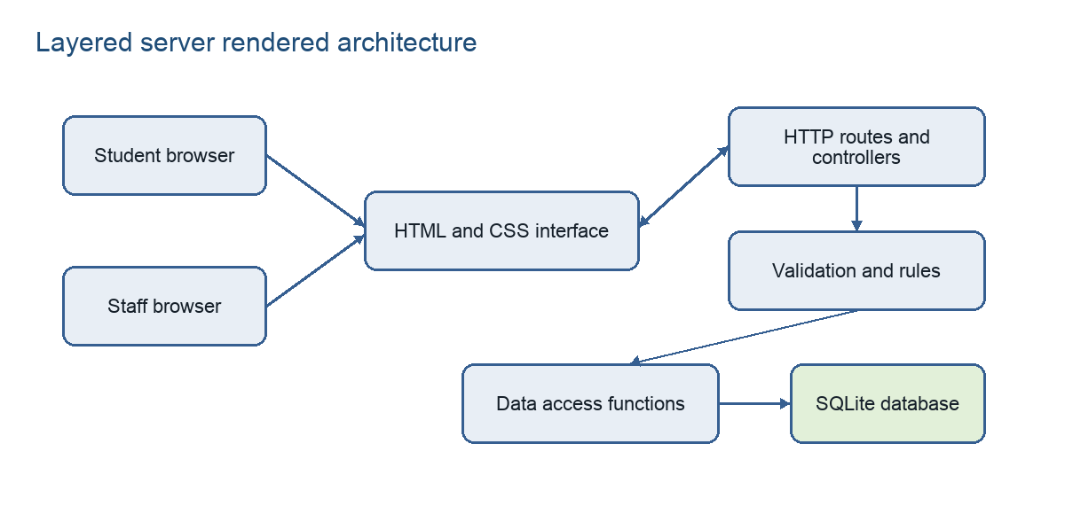
Figure 1: Layered architecture used by the prototype.
Layer | Main responsibility | Requirements supported
Interface | Student browse pages, profile pages and staff workspace screens. | UR4, UR5, UR7, FR4, NFR1, NFR6
Routes | GET and POST handlers select the correct page, action and response. | FR1, FR2, FR3, FR4
Validation | Checks required fields, email format, capacity range and allowed project status. | NFR3
Data access | Named functions create, read, update and delete staff, areas and projects. | FR1, FR2, FR3, NFR5
Persistence | SQLite stores staff profiles, areas of interest and project ideas. | NFR2

2.2 Data Model
The data model follows the problem definition. One staff member can have many areas of interest and many project ideas. The separate area and project tables avoid storing repeated lists inside one staff record. Foreign keys with cascade deletion stop deleted staff records from leaving unused interests or projects behind.
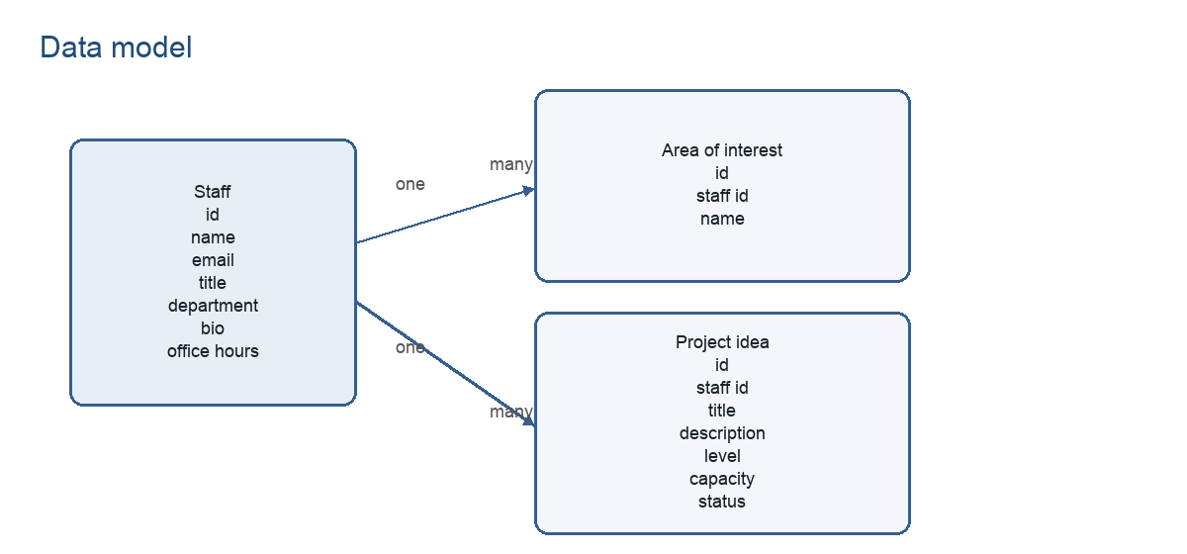
Figure 2: Staff, area of interest and project idea data model.
2.3 Use Case Model
The use case model focuses on the two actors required by the brief. Student use cases cover browsing, searching and profile viewing. Staff use cases cover profile maintenance, areas of interest and project ideas. Login, logout and registration are not used as representative use cases because the brief excludes them from the use case requirement.
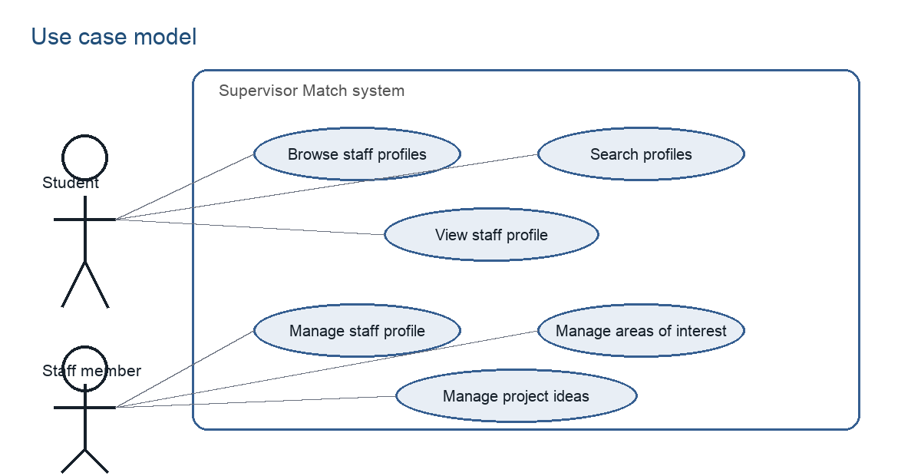
Figure 3: Representative use cases for student and staff actors.
2.4 Detailed Use Case Specifications
Use case | Specification
UC1 Browse staff profiles | Actor: Student. Preconditions: profiles exist. Trigger: the student opens the browse page. Main flow: the system retrieves staff summaries and shows names, departments, interests and project counts. Alternative flow: if no profiles exist, an empty message appears. Postcondition: the student can select a profile. Links: UR4, FR4, NFR1, NFR6.
UC2 Search profiles and projects | Actor: Student. Preconditions: staff profiles exist. Trigger: the student enters a search term. Main flow: the system normalises the term and matches staff details, interests and project titles. Alternative flow: a blank query returns all profiles and no match shows an empty message. Postcondition: filtered results remain visible. Links: UR5, FR4, NFR4.
UC3 View staff profile | Actor: Student. Preconditions: a selected profile exists. Trigger: the student selects view profile. Main flow: the system shows biography, office hours, interests and project ideas with level, capacity and status. Alternative flow: an unknown profile returns a not found response. Postcondition: the student has enough detail to compare options. Links: UR4, UR6, FR4.
UC4 Manage areas of interest | Actor: Staff member. Preconditions: the profile edit page is open. Trigger: staff add or remove an interest. Main flow: the system validates non empty text, saves the interest and returns to the edit page with confirmation. Alternative flow: blank input is rejected. Postcondition: the area list is updated consistently. Links: UR2, FR2, NFR2, NFR3.
UC5 Manage project ideas | Actor: Staff member. Preconditions: a staff profile exists. Trigger: staff create, edit or delete a project idea. Main flow: required fields and capacity are validated, then the project is saved and displayed publicly. Alternative flow: invalid capacity or missing required text is rejected. Postcondition: project information is created, updated or deleted and persists in SQLite. Links: UR3, UR6, FR3, NFR2, NFR3.

Chapter 3: Implementation
3.1 Submitted Links
Code repository: GitHub repository
Demo recording: Demo recording
Complete test plan: SETAP test plan workbook
Automated tests: Automated test file
The implementation is a local web prototype written with the Python standard library, SQLite, server generated HTML and CSS. This stack was selected because it keeps the prototype easy to run, inspect and test while still supporting persistence and complete staff workflow actions.
3.2 Implemented Features
Requirement | Implementation evidence
FR1 | The staff workspace allows staff profile creation, editing and deletion through the admin routes and the create_staff, update_staff and delete_staff functions.
FR2 | Areas of interest can be added and removed from the staff edit page using create_area and delete_area.
FR3 | Project ideas can be created, edited and deleted with title, description, level, capacity and status fields.
FR4 | Students can open the staff browse page, search profiles and view a staff profile with interests and project ideas.
NFR2 | SQLite persistence is created on first run and is tested across reopened database connections.
NFR3 | The validate_staff and validate_project functions reject missing fields, invalid email, duplicate email and invalid project capacity.
NFR6 | The stylesheet includes a responsive breakpoint for mobile width layouts.

3.3 Code Quality
The code is intentionally small, but it is structured so that the main responsibilities are visible. Database setup, seeding, validation, data access and route handling are separated into named functions. This helps the implementation map back to the requirements and makes the important logic testable without needing a browser for every case.
The repository includes the main app file, static styling, tests, design evidence, interview analysis, the workbook test plan and the demo recording. Git commits record the build in stages, including the prototype, evidence documents, demo materials and final test plan workbook.

Chapter 4: Testing
4.1 Testing Strategy
Testing combines automated tests for core logic with manual browser tests for user workflows. The automated tests focus on data creation, validation, search, persistence and output escaping. The manual test plan covers visible browser behaviours such as browsing, creating a staff profile, adding interests, adding project ideas, editing availability and checking responsive layout.
The workbook test plan uses partition testing. It includes valid inputs, invalid inputs, boundary values and no result cases. This directly addresses the marking requirement for a complete test plan with evidence that different input partitions have been considered.
4.2 Automated Test Evidence
Item | Evidence
Command | python3 module unittest discover from tests with verbose output
Date run | 30 July 2026
Result | 11 tests run, 11 passed, 0 failed and 0 skipped
Duration | 0.029 seconds on the development machine
Coverage | Database seeding, topic search, staff validation, staff profile management, project management, areas, persistence, duplicate email protection, output escaping and responsive CSS.

4.3 Requirement Coverage
Requirement | Test evidence
FR1 | Automated create, update and delete staff profile tests plus manual workflow cases in the test plan.
FR2 | Automated create and delete area test plus invalid blank area partitions in the workbook.
FR3 | Automated project create, update, delete and capacity boundary tests plus invalid status and missing field partitions.
FR4 | Automated browse and search tests for area and project title matches plus manual browse and inspect cases.
NFR1 | Responsive CSS breakpoint test and manual mobile width inspection case.
NFR2 | Automated persistence test across database connections.
NFR3 | Automated validation tests for missing staff fields, invalid email, duplicate email and project capacity.
NFR4 | Manual local timing case in the workbook test plan.
NFR5 | Repository structure, named functions and requirement linked test plan evidence.
NFR6 | Manual Safari or Chrome browser compatibility case in the workbook test plan.

4.4 Evaluation And Limitations
The implemented prototype passes the automated test suite and covers the core workflows required by the brief. The strongest testing evidence is the connection between requirements, partition based manual cases and automated unit tests. This makes it clear which requirement each test supports.
The main limitation is that authentication and authorisation are outside this prototype. The staff workspace is open for demonstration, so a production version would need secure staff accounts before deployment. The search is also a simple SQL keyword search rather than ranked relevance. Future work should add login, last updated dates, favourites, availability filters and formal accessibility testing.
Final Marking Alignment Checklist
Marking area | Evidence in this submission
Problem specification process | Chapter 1 explains participants, method design, motivation, data collected, analysis process, themes and limitations.
User requirements | Chapter 1 lists user requirements with participant and brief sources.
System requirements | Chapter 1 translates user requirements into functional and non functional requirements with acceptance criteria.
Architecture | Chapter 2 names the layered server rendered architecture, explains components and maps them to requirements.
Use cases | Chapter 2 includes a use case diagram and five detailed representative use case specifications.
Implementation | Chapter 3 includes the repository, demo recording, implemented features and code quality evidence.
Testing | Chapter 4 includes automated test results, a complete workbook test plan and requirement coverage evidence.

References
University of Portsmouth. (2026). SETAP referral and deferral coursework brief. School of Computing.

